preparing people for purpose
ADVANCING THE KINGDOM OF GOD

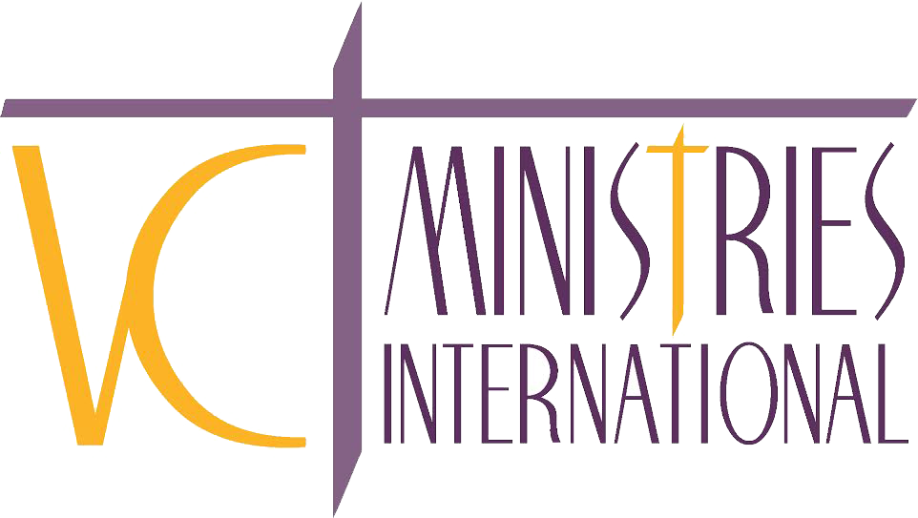

HANDBOOK

625 Harrison St
Kalamazoo, MI 49007
Phone (269) 251-2448
Fax (269) 276-0201
vcministriesintl.com

Table of Contents
VCMI Mission and Vision 3
Who We Are 3
VCMI Host Events 4
Benefits of Covenant Membership 4
Expectations 4
Code of Ethics 4,5
Where You Fit 5
Spiritual Covering 5
Statement of Biblical Beliefs 5,6

OUR MISSION

To educate, equip and empower people to live life on purpose.

OUR VISION

Work with visionaries to master their place of purpose for Kingdom advancement!

WHO WE ARE
Valarie Cunningham Ministries International (VCMI) is NOT a denomination but rather a network of businesses, ministries, and churches, united for the purpose of advancing the Kingdom of God. VCMI is an Apostolic/Prophetic Ministry operating under the leadership philosophy of servanthood, relationship, responsibility ,and empowerment. The synergy that is produced causes us to accomplish more together than we could ever do individually. The function of the VCMI Network is to connect senior leaders and visionaries in the faith This is the time where people are going to want to be in covenant with you because they know the power of God that operates in your life, not because they love your God but because of the benefits you bring to the table. We have to be aware in this season to not misalign ourselves and come into covenant relationships or establish oaths with people who are not going in the same direction.

HISTORY
VCMI was birthed after years of waiting on the voice of God for direction in 2014. It was launched at a 3-day revival called the Daughters of Thunder where God moved mightily under the anointing of other Prophets and Pastors. Prior to launching VCMI, Apostle Valarie had received extensive prophetic training from Eagle Lion Institute in Marion, OH, from 2006-2009 and believes in the power of being equipped and trained properly in your area of gifting and calling. VCMI has traveled internationally, doing mission work in Mexico, Trinidad, and Africa. The VCMI Network has grown many prophetic sons and daughters and covers churches, para-church ministries, and businesses. In 2016, VCMI Network launched its internationally in Kenya, Africa and in 2018, Kingdom Empowerment Institute Kenya was launched reaching the nations of Tanzania, Uganda, Rwanda, and many other counties in Kenya and over 12 denominations. Apostle Valarie continues to embrace the call of educating, equipping, and empowering many sons and daughter to live life on purpose. Apostle Valarie not only has over 37 years of ministry experience, she also has over 24 years in the Marketplace and over 16 years of being the CEO of her own non-profit organization. She has special abilities to bridge the gap between market-place and ministry.

VCMI HOST EVENTS
Prophetic Awakening
Prophetic Empowerment Encounters
Gathering of the Twelve
Prophetic Awakening International Conference

BENEFITS OF COVENANT MEMBERSHIP
- Ongoing relationship with VCMI and other Network members
- Combined impact in missions
- Accountability through peer relationship and apostolic oversight
- Prayer and advice from our Network Ambassadors
- Spiritual Covering for church, ministry or business owners desiring a father/son relationship with Apostle Valarie Cunningham
- Access to regional gatherings, retreats, webcasts, and VCMI Network events
- VCMI associates, interns, and Prophetic Teams are trained and prepared for activation
- A member-only discount for those attending the spring and fall Network Advance
- Leadership training for set gifts, visionaries, and their staff
- Ordination
- Optional federal tax exemption for those who qualify

EXPECTATIONS
Members are strongly encouraged, but are not mandated, to attend at least one VCMI event or trip each year. If the senior leader or visionary cannot attend, a representative from the church or ministry could take their place and take back a report of what they experienced.

Invite Apostle Valarie Cunningham or a VCMI team member to visit your church, para-church ministry or business within the first year of membership further details discussed upon invitation).

Members should submit a yearly administration fee by January 31 each year of membership. Members are also required to participate in financially supporting VCMI at some level. This can be done as an annual or monthly donation. We do not ask for a percentage as some networks do, but we ask each member to pray and determine the contribution they can make.

CODE OF ETHICS
Members must conduct their personal life, family, finances, and ministry in agreement with the principles and moral standards of Scripture. They should hold an exemplary reputation and testimony with those outside of the body of Christ.

If there is evidence of questionable testimony (an ungodly lifestyle, sexual misconduct, financial misappropriation, or constant divisive behavior) the member must submit to a process of discipline/restoration in relationship with VCMI Network. If members will not comply with the discipline process, affiliations may be withdrawn at any time.

WHERE YOU FIT
"Two are better than one; because they have a good reward for their labor." Ecclesiastes 4:9. When we work together, we can maximize our strength for the Kingdom and get much more done. VCMI Network provides a starting place, a gathering of like-minded people to be sent to do the work of ministry on the front line. Becoming a part of this Network, you will not only be connecting and building with VCMI and Apostle Valarie Cunningham, but with other senior leaders, visionaries, and ministry leaders worldwide. Each person can reap the value of connection. “From whom the whole body, being fitted and held together by what every joint supplies, according to the proper working of each individual part, causes the growth of the body for the building up of itself in love.” Ephesians 4:16. You will be able to build relationships with other ministry leaders within the Network, regionally and globally and expand the reach and vision that God has placed in you.

SPIRITUAL COVERING
VCMI provides business owners, ministry leaders and Para church ministry leaders spiritual covering. Under VCMI Network they will have priority concerning Apostolic Council, apostolic-prophetic training leadership growth and development, international travel, advances, seminars etc. through Kingdom Empowerment Institute (KEI) and Kingdom Apostolic Network. Those covered by VCMI Network will have opportunities to do ministry not only on a local level but will be a part of Apostolic- Prophetic teams that travel throughout the USA and do work overseas when opportunities arise. This will help to expand our reach and fulfill the “Great Commission.”

STATEMENT OF BELIEF
STATEMENT of BIBLICAL BELIEFS -GOD
•God is a true God consisting in spirit as three distinct Persons or Positions: Father, Son and Holy Spirit.

•Jesus Christ is the only begotten Son of the Father and is God incarnate, being the fullness of the Godhead bodily and Savior of the world.

References: Matthew 28:19; 3:16-17; I John 5:7, 8; John 14:6-17; Col. 2:9; Is. 48:16

STATEMENT of BIBLICAL BELIEFS-HOLY SPIRIT
The Holy Spirit through the will of the believer operates in all believers in the power of the gifts of the Spirit, manifesting them as He wills for:
1) Christian service and ministry;
2) increased effectiveness in prayer;
3) the winning of souls;
4) revelation knowledge; and,
5) working of signs and wonders and miracles (including healing the sick). As a witness to this generation that God is God and is present in the NOW to deliver a lost and suffering humanity –and to prepare them to be the Bride of Christ at His personal bodily return.

•The Holy Spirit operates as the unlimited and invisible presence of Jesus Christ on earth as Comforter and Advocate, indwelling every born-again believer and making the believer’s body His temple.

•The Holy Spirit convicts of sin, draws the sinner to Christ, and inspires faith in him to repent of sin and believe within his heart that God raised Jesus Christ from the dead and to confess with his mouth that Jesus is his personal Savior and Lord.

References: I Cor. 2:10; John 15:26; I John 5:6; John 14:26; Neh. 9:20; Acts 8:29; 10:19; 16:6,7; Rom. 8:26; Matt. 4:1; John 16:13; John 3:5,6; John 16:8; Acts 13:2; 20:28; I Cor. 12: 7-11

STATEMENT of BIBLICAL BELIEFS –JESUS CHRIST/GREAT COMMISSION
•The Savior of fallen man is the eternal Son of God, conceived by the Holy Spirit of the Virgin Mary, made fully God and fully man in the incarnation, whose death and resurrection for our sins is our only hope of salvation of spirit, soul, and body in this life and the world to come.
•The Great Commission was given by Christ and is binding on every believer to “go into the world and preach the gospel to every creature”.

References: Is. 7:14; 9:6-9; Micah 5:2; Ps. 2:7, 12; 45:6; Gen. 3:15, 22:18; Lk 1:26-35; Jer. 31:22;
Mark 16:15; Matt 28:19

STATEMENT of BIBLICAL BELIEFS –THE HOLY SCRIPTURES
•All of the Scriptures are to be interpreted in their context and purpose.

•The Scriptures shall not be added to, superseded, or changed by later tradition or revelation.

•The Holy Scriptures and its translations, not modern versions, is the infallible Word of God and is therefore without error and is eternally reliable in all matters of a Christ centered faith and practice.

•Every doctrinal formation, whether of creed, confession, or theology, must be put to the test of the full counsel of God as revealed in the Scriptures consisting of 66 books, from Genesis to Malachi in the Old Testament and from Matthew to Revelation in the New Testament.

References: 2 Tim. 3:16; Gen. 2:7; Acts 17:25; Job 32:8; 2 Peter 1:21; Ex. 17:14; 2 Peter 1:20-21; Jer. 30:2

